High Sensitivity Cardiac Troponin
Why do we need high sensitivity troponin?
- Better precision offers improved discrimination at diagnostic decision levels
- Allows for the detection of smaller infarcts
- Allows for the potential use of accelerated diagnostic protocols (ADP) for the more rapid triage of patients
- The use of ADPs can reduce ED wait times and shorten patient turnaround times in the ED
- More efficient and potentially better patient care

Definition of High Sensitivity Troponin
- The %CV at the 99th percentile should be ≤ 10%
- At least 50% of healthy individuals should have measurable concentrations above the Limit of Detection (LoD*) and below the 99th percentile.

*LoD is defined as the value generated in a biological sample having the lowest measurable analyte concentration that is distinguishable from the limit of the blank (LoB)

Criteria for Type 1 MI
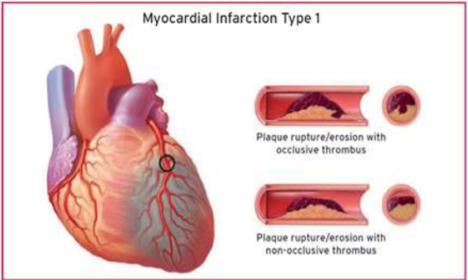
Detection of a rise and/or fall of cTn values with at least one value above the 99th percentile URL and with at least one of the following:
- Symptoms of acute myocardial ischemia
- New ischemic ECG changes
- Development of pathological Q-waves
- Imaging evidence of new loss of viable myocardium or new regional wall motion abnormality in a pattern consistent with an ischemic etiology
- Identification of a coronary thrombus by angiography including intracoronary imaging by autopsy

Criteria for Type 2 MI

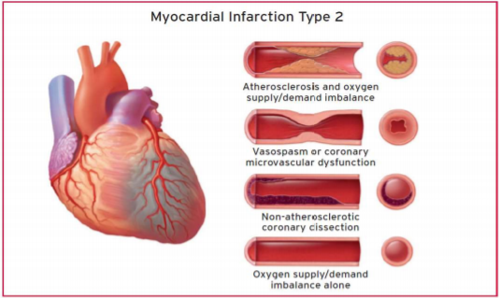
Detection of a rise and/or fall of cTn values with at least one value above the 99th percentile URL and evidence of an imbalance between myocardial oxygen supply and demand unrelated to coronary thrombus, requiring at least one of the following:
- Symptoms of acute myocardial ischemia
- New ischemic ECG changes
- Development of pathological Q-waves
- Imaging evidence of new loss of viable myocardium or new regional wall motion abnormality in a pattern consistent with an ischemic etiology

Journal of the American College of Cardiology August 2018
Some Comments from the Fourth UDMI
  - Cardiac troponin is the preferred biomarker for the evaluation of myocardial injury, and high-sensitivity assays are recommended for routine clinical use.
  - The definition of MI includes a significant rise and/or fall pattern of troponin results and should be used along with clinical interpretation (e.g. History, ECG, HEART Score, etc.)
  - It is recommended that high sensitivity troponin should be:
  - Reported in ng/L and using whole numbers.
  - Reported using sex-specific 99th percentile ranges.
  - High Sensitivity Troponin assays support the use accelerated diagnostic protocols of 1-2 hours
  - Strategies employing either very low levels of hs-cTn on presentation or the lack of any change over a 1 or 2 h period after presentation have been advocated to exclude myocardial injury and MI (the NPVis better than the PPV).
  - Definition of “significant change” (rise and/or fall) with respect to 99th percentile value:
- If the patient’s result is < 99th percentile: at least a 50-60% change
- If the patient’s result is > 99th percentile: at least a 20% change
- Absolute changes are assay dependent but appear superior to relative percent changes

Journal of the American College of Cardiology August 2018

Reasons for the Elevation of Cardiac Troponin
Values Because of Myocardial Injury
- Myocardial Injury Related to Acute Myocardial Ischemia
Atherosclerotic plaque disruption with thrombosis
- Myocardial Injury Related to Acute Myocardial Ischemia because of oxygen supply/Demand Imbalance
A ) Reduced myocardial perfusion
  - Coronary artery spasm
  - Microvascular dysfunction
  - Coronary embolism
  - Coronary artery dissection
  - Sustained bradyarrhythmia
  - Hypotension or shock
  - Respiratory failure
  - Severe anemia
B ) Increased myocardial oxygen demand
  - Sustained tachyarrhythmia
  - Severe hypertension with or w/o ventricular hypertrophy
- Other Causes of Myocardial Injury
Cardiac conditions
- Heart failure
- Myocarditis
- Cardiomyopathy (any type)
- Takotsubo cardiomyopathy
- Coronary revascularization procedure
- Cardiac procedures other than revascularization
- Catheter ablation
- Defibrillator shocks
- Cardiac contusion
Systemic conditions
  - Sepsis, infectious disease
  - Chronic kidney disease
  - Stroke, Subarachnoid hemorrhage
  - Pulmonary embolism
    - Pulmonary hypertension
    - Infiltrative diseases, e.g. amyloidosis, sarcoidosis
    - Chemotherapeutic agents
    - Critically ill patients
    - Strenuous exercise
4 th UDMI Am Coll Card Aug 7, 2018

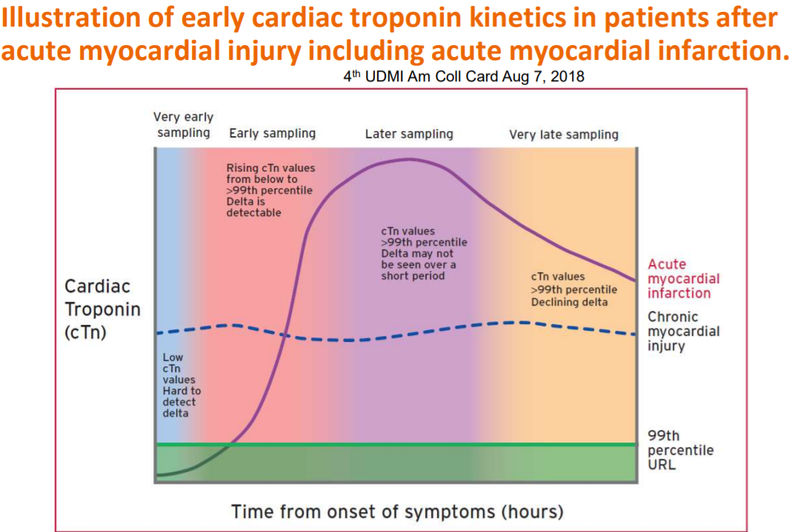

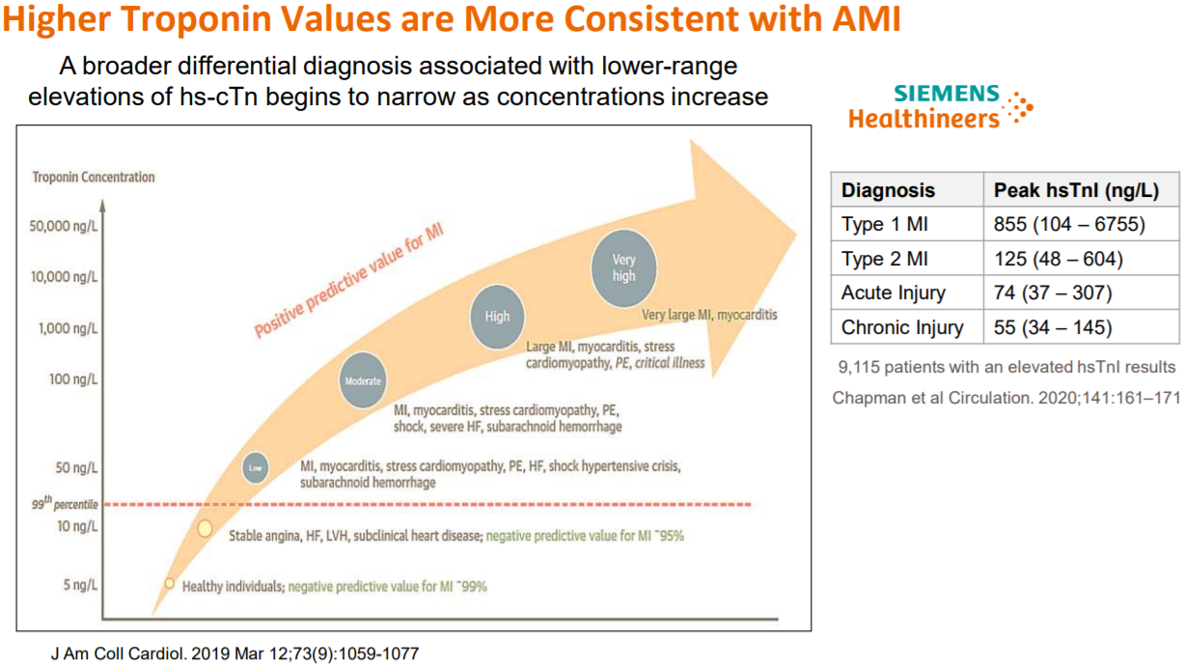

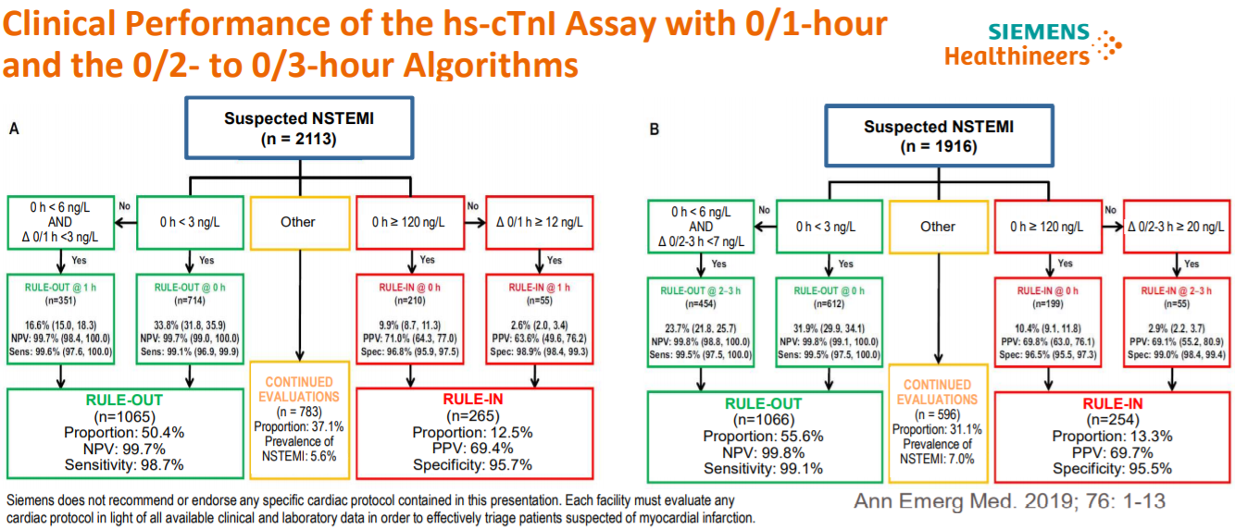

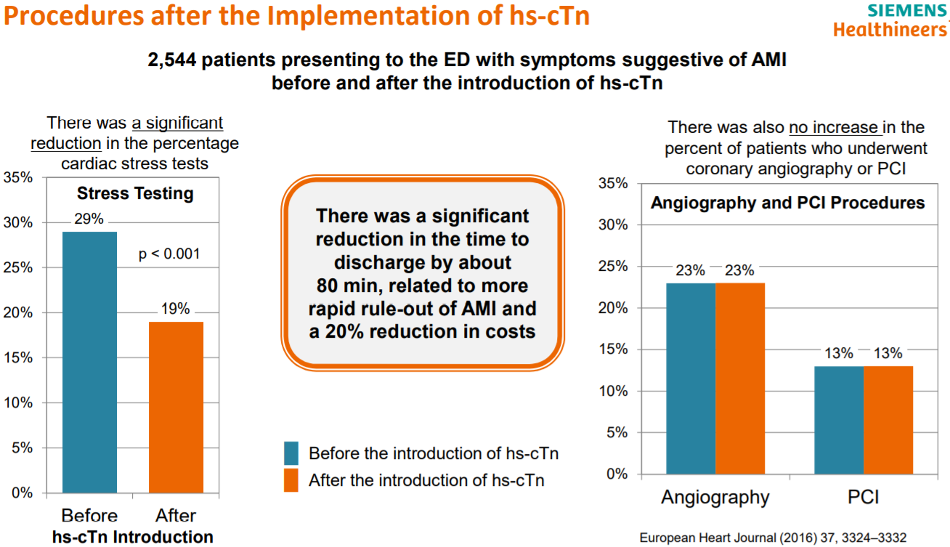

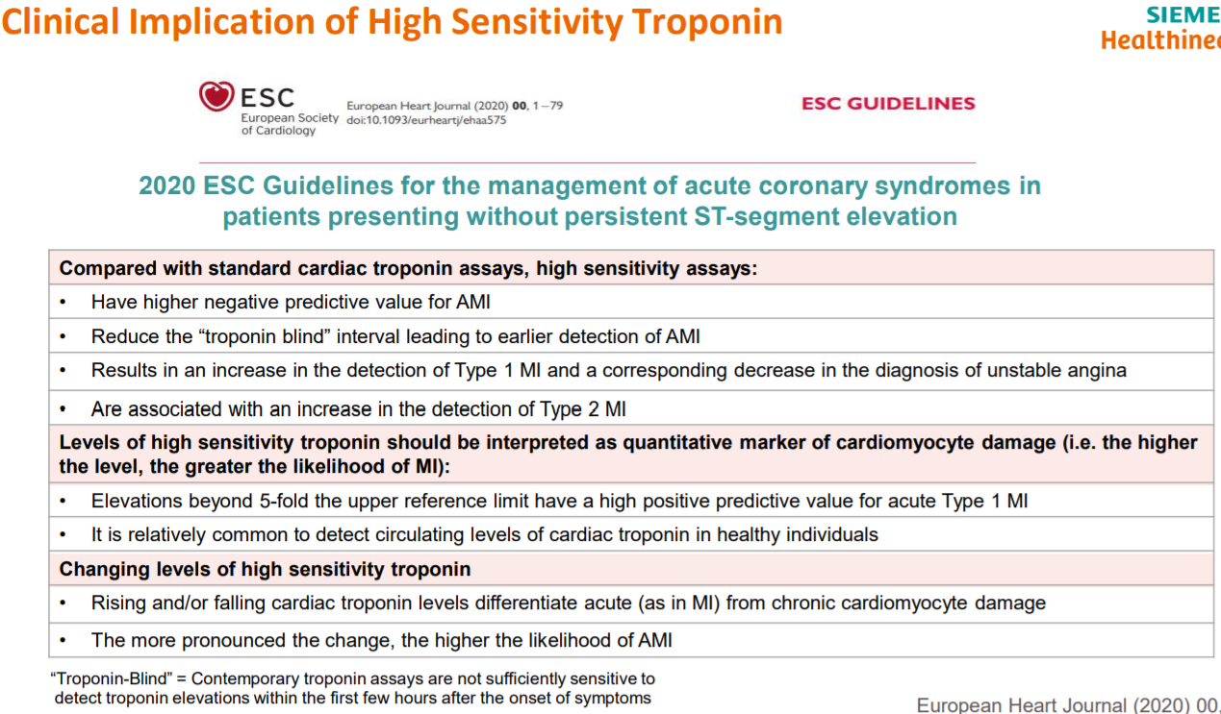

Take Home Messages
  - High sensitivity troponin assays have improved precision at the medical decision level
  - High sensitivity troponin assays have a demonstrated clinically significant difference in the 99th percentiles for males and females with males being higher than females.
  - High sensitivity troponin allows for the use of accelerated diagnostic protocols which can potentially shorten the time to rule-out patients suspected of an MI.
  - Troponin is a better rule-out test than a rule-in test.
  - The negative predictive value is better than the positive predictive value.
  - There is no universal standard for troponin, therefore, it is important to use the same troponin assay to assess changes in patient’s troponin results over time.
  - Some high sensitivity troponin assays are known to have a significant interference form biotin. The Siemens high sensitivity troponin that is free* from biotin interference thereby making patient results more reliable.

* Less than 10% bias at biotin levels up to 3500 ng/mL

Contact Information Jim Aguanno, PhD
Senior Clinical Consultant Scientific and Clinical Affairs
james.aguanno@siemens-healthineers.com
Cell: 972-567-7777

UpToDate
UpToDate
- A high sensitivity troponin assay was first approved for use in the United States in 2017.
- Since an elevated troponin is essential for the diagnosis of acute MI, two normal troponins (if appropriately timed) can, in theory, exclude MI in most cases, assuming the criteria are sufficiently robust. However, many of these protocols rule in acute myocardial injury based on an elevated high sensitivity troponin and/or a significant change in values.
- It should be appreciated that there will be a significant increase in the number of elevated results seen with hs-cTn assays that reflect conditions other than those related to acute atherothrombotic coronary artery disease. There will be more events detected in women, and more events in those with minimal coronary disease and without overt culprit lesions; such patients presumably require different therapies than those with acute atherothrombotic MI.

Type I versus type II MI
Most patients who are found to meet criteria for acute MI will have acute obstructive atherosclerotic coronary artery stenoses with acute thrombosis as the underlying pathology. However, some patients (up to 28%) will not have significant epicardial coronary artery disease when coronary angiography is performed. Many of these patients are defined as having a Type 2 MI, which is defined as an MI consequent to increased oxygen demand or decreased supply:
Coronary endothelial dysfunction,
Coronary artery spasm,
Coronary artery embolus,
Tachy-/bradyarrhythmias,
Anemia,
Respiratory failure,
Hypertension, or
Hypotension.
Many of these patients can also have coronary artery disease that will modulate the ischemic threshold and thus the severity of any given stressor that might ischemia .
With the use of previous non-high sensitivity assays, patients with acute ischemia and an elevated troponin value benefited from diagnostic coronary angiography and possible percutaneous coronary intervention. This is not nearly as clear with hs-cTn assays since the increased sensitivity of these assays means that larger numbers of patients with type 2 acute MI will be detected; these patients may not benefit from an invasive approach.
It may be useful for clinicians to be aware of how the values with prior standard assays compare with high sensitivity ones. Since the advocacy for an invasive strategy was based on elevations of the standard assays, results above the value with the hs-cTn assay that comport to the prior value may be helpful to clinician. These values have been termed "anchor values" by some. For example, a value of:
30 ng/L with the 5th generation hs-cTnT/ comports to a value of 0.01 ng/mL with the 4th generation assay
52 ng/L to a value of 0.03 ng/mL.
For some hs-cTnI assays, the 99th percentile URLs will remain the same. For others, the appropriate conversions will need to be developed.

Differential diagnosis
For patients with an acute or subacute clinical presentation, at least four other causes of moderately or markedly elevated of troponin have been identified other than chronic elevations such as in end stage renal disease and rare analytical causes:
- Acute myocarditis is the diagnosis most apt to mimic acute (thrombotic) MI, both in terms of clinical presentation and troponin results, particularly when the troponin is very elevated. In a series of 60 patients who presented with possible acute MI but had normal coronary arteries, 30 (50%) had magnetic resonance imaging features of acute myocarditis. Thus, acute myocarditis should be a consideration in patients, especially women, who present in this manner and have normal coronary arteries. One approach might be to use cardiovascular magnetic resonance imaging to determine the source of myocardial damage in a patient with elevated troponin levels but without obstructive coronary disease at invasive coronary angiography.
- Takotsubo syndrome ("stress cardiomyopathy") should also be considered, but in general, elevations of cTn are more modest in this condition.
- Pulmonary embolism with acute right heart overload and heart failure can have a rising and/or falling pattern of hs-cTn values and thus mimic acute MI. The troponin elevations are more often modest in these disorders and, among patients with pulmonary embolism, usually resolve within 40 hours in contrast to the more prolonged elevation with acute myocardial injury.
- Troponin release can be induced by trauma, as occurs during:
- Cardiopulmonary resuscitation,
- Electrical cardioversion(3/38 patients had minimal elevations of cTnI)
- Implantable cardioverter defibrillator firings.
There is no single threshold hs-cTn value that reliably discriminates any of these causes. The use of serial values to assess for a dynamic rise or fall in concentration, the absolute concentration, and the clinical syndrome should all be integrated by the clinician to make an assessment regarding the cause of myocardial injury.

Reinfarction — Troponins can also be used for detecting reinfarction, which is an acute MI that occurs within 28 days of an incident or recurrent MI [1]. If reinfarction is suspected, an immediate measurement of cardiac troponin should be made [1]. A second sample is obtained three to six hours later, and recurrent infarction is present if there is a ≥20 percent increase in the second sample.

